

**CS-114 - Fundamental of Programing**

**Lab Manual # 5**

**Lab Task**

Submitted To: Muhammad Affan

Submitted By: Shahzaib Murtaza (466034)

Section: B

**1.Convert the following while loop to a do-while loop:**

int x = 1;

while (x > 0)

{

cout << "enter a number: ";

cin >> x;

}

#include <iostream>

using namespace std;

int main(){

int x=1;

do{

cout<<"enter number:";

cin>>x;

}

while(x>0);

return 0;

}

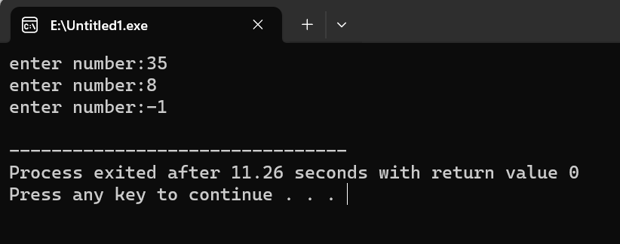

**2. Use a do while loop to make a simple calculator for two numbers. Insert buttons for it to ask again and for termination.**

#include <iostream>

using namespace std;

int main(){

double num1,num2,result;

char op, con;

do{

cout<<"Enter Number:";

cin>>num1;

cout<<"Enter Number:";

cin>>num2;

cout<<"input operator:";

cin>>op;

switch(op){

case '+':

result=num1 + num2;

break;

case '-':

result=num1 - num2;

break;

case '*':

result=num1 * num2;

break;

case '/':

result=num1 / num2;

break;

default:

cout<<"Input a valid operator";

}

cout<<"Result:"<<result<<endl;

cout<<"Press 'C' to continue"<<endl;

cout<< "Press anything to end"<<endl;

cin>>con;

}

while(con=='C');

return 0;

}

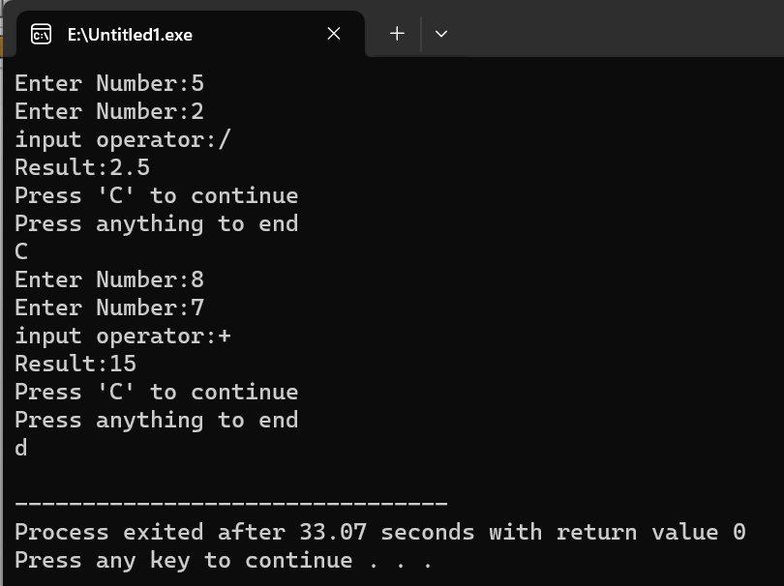

**3. Write programs with while or do while loops that compute:**

**a) The sum of all even numbers between 2 and 100 (inclusive).**

#include <iostream>

using namespace std;

int main(){

int sum=0,a=2;

while(a<=100){

sum=sum + a;

a+=2;

}

cout<<"Sum of all even numbers from 2 to 100 (inclusive): "<<sum<<endl;

return 0;

}

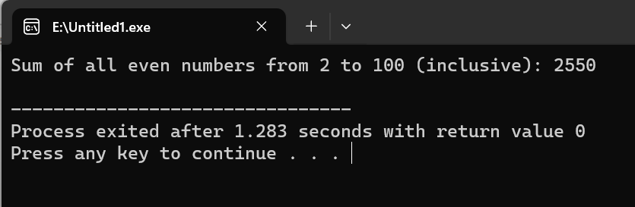

**b) The sum of all squares between 1 and 100 (inclusive).**

#include <iostream>

using namespace std;

int main(){

int square,a=1,b=0;

while(a<=10){

square=a*a;

b=square+b;

a++;

}

cout<<"Sum of all squares between 1 and 100 (inclusive): "<<b<<endl;

return 0;

}

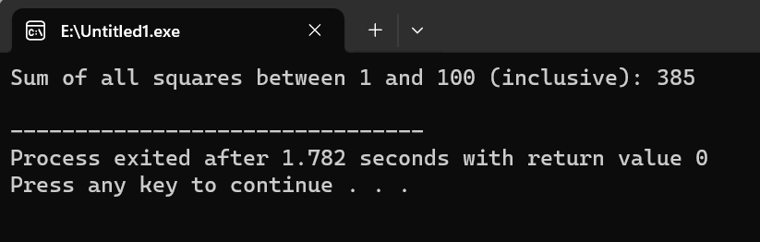

**4. Write programs with while or do while loops that compute:**

**a) All powers of 2 from 20 up to 220.**

#include <iostream>

#include <cmath>

using namespace std;

int main(){

int number=0,a;

cout<<"Powers from 2^0 to 2^20:"<<endl;

while(number<=20){

a=pow(2,number);

cout<<"2^"<<number<<"=";

cout<<a<<endl;

number++;

}

return 0;

}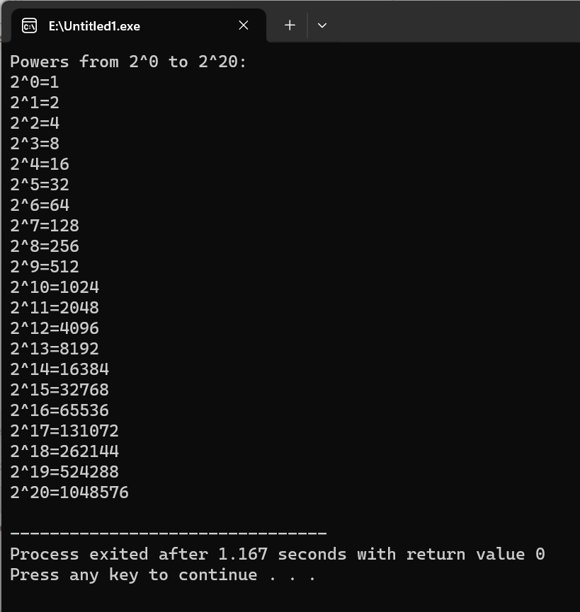

**b) The sum of all odd numbers between a and b (inclusive), where a and b are inputs.**

#include <iostream>

using namespace std;

int main(){

int a,b,sum=0;

cout<<"Enter first number : ";

cin>>a;

cout<<"Enter second number : ";

cin>>b;

cout<<"Sum of all odd numbers between "<<a<<" and "<<b<<" = ";

while(a<=b){

if(a%2!=0){

sum=sum+a;

}

a++;

}

cout<<sum;

return 0;

}

